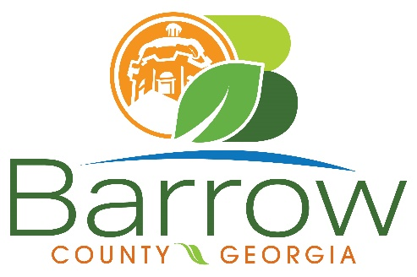
Planning & Community Development
30 North Broad Street
Winder, GA 30680
(770) 307-3034
planning@barrowga.org

2025 Public Hearing & Application Submittal Dates
Applications are accepted all month long!

Applications Submitted between these dates will be heard at the coordinating meeting date | Planning Commission Meeting Date | Board of Commissioners Meeting Date | Board of Appeals Meeting Date
10/22/2024 - 11/18/2024 | 1/16/2025 | 2/11/2025 | 1/09/2025
11/19/2024 - 12/16/2024 | 2/20/2025 | 3/11/2025 | 2/13/2025
12/17/2024 - 1/27/2025 | 3/20/2025 | 4/08/2025 | 3/13/2025
1/28/2025 - 2/24/2025 | 4/14/2025 | 5/13/2025 | 4/10/2025
2/25/2025 - 3/31/2025 | 5/15/2025 | 6/10/2025 | 5/08/2025
4/1/2025 - 4/28/2025 | 6/17/2025 | 7/08/2025 | 6/12/2025
4/29/2025 - 5/27/2025 | 7/17/2025 | 8/12/2025 | 7/10/2025
5/28/2025 - 6/30/2025 | 8/21/2025 | 9/9/2025 | 8/14/2025
7/1/2025 - 7/28/2025 | 9/18/2025 | 10/14/2025 | 9/11/2025
7/29/2025 - 8/25/2025 | 10/16/2025 | 11/11/2025 | 10/09/2025
8/26/2025 - 9/29/2025 | 11/20/2025 | 12/09/2025 | 11/13/2025
9/30/2025 - 10/27/2025 | 12/18/2025 | 1/13/2026 | 12/11/2025
10/28/2025 -11/24/2025 | 1/15/2026 | 2/10/2026 | 1/08/2026
11/25/2025 - 12/29/2025 | 2/19/2026 | 3/10/2026 | 2/12/2026
12/30/2026 - 1/26/2026 | 3/19/2026 | 4/14/2026 | 3/12/2026

